Day 11 Assignment

1. Fix the bugs in below snippet

Code:

<html lang="en">

    <head>

        <title>Document

            <body>

                guvi

        </title>

    </head>

    <div>

        Lorem ipsum dolor sit amet consectetur adipisicing elit.

        <div>

            <div>

                Guvi Geek Network

            </div>

        </body>

    </html>

Corrected code:

<html lang="en">

    <head>

        <title>

            Document guvi

         </title>

    </head>

    <body>

        <div>

        Lorem ipsum dolor sit amet consectetur adipisicing elit.

        </div>

        <div>

                Guvi Geek Network

        </div>

    </body>

</html>

OUTPUT:

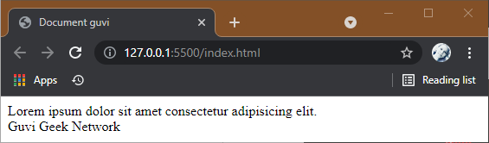

1. Try the below one

<html lang="en">

<head>

<title>Document

<body>

guvi

</head>

<div>

Lorem ipsum dolor sit amet consectetur adipisicing elit.

<div>

<div>

Guvi Geek Network

</div>

</body>

</html>

Corrected Code:

<html lang="en">

    <head>

        <title>Document</title>

    </head>

        <body>

                guvi

            <div>

        Lorem ipsum dolor sit amet consectetur adipisicing elit.

            </div>

            <div>

                Guvi Geek Network

            </div>

        </body>

</html>

Output:

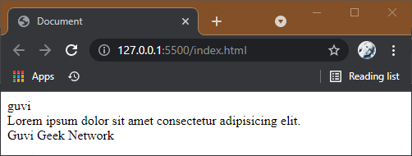

3. Design a contact us form with all fields as required

 <html lang="en">

<head>

    <meta charset="UTF-8" />

    <meta http-equiv="X-UA-Compatible" content="IE=edge" />

    <meta name="viewport" content="width=device-width, initial-scale=1.0" />

    <title>Document</title>

    <link rel="stylesheet" href="css/style.css" />

  </head>

  <body>

    <header>Contact Us</header>

    <form>

      <label for="Firstname">Firstname</label>

      <input type="text" name="Firstname" placeholder="Firstname" /><br />

      <label for="Password">Password</label>

      <input

        type="password"

        name="Password"

        placeholder="Enter your Password"

      /><br />

      <label for="phone">Phone</label>

      <input type="text" name="phone" placeholder="Enter your Mobile number"/

      ><br />

      <label for="email">Email</label>

      <input type="email" name="email" placeholder="Mail-id" /><br />

      <label for="message">Message</label><br />

      <textarea name="message" rows="5" cols="50"></textarea><br />

      <input type="submit" name="Submit" value="Submit" />

    </form>

  </body>

</html>

CSS

header{

*font-size*:40px;

*font-weight*:bolder;

*text-align*:center;

}

body{

*font-family*:'Franklin Gothic Medium', 'Arial Narrow', Arial, sans-serif;

*background*:linear-gradient(#647dee,#7f53ac)

}

form{

*white-space*:pre-line;

*padding*:10px;

*border-radius*:5px;

*font-weight*:500 ;

}

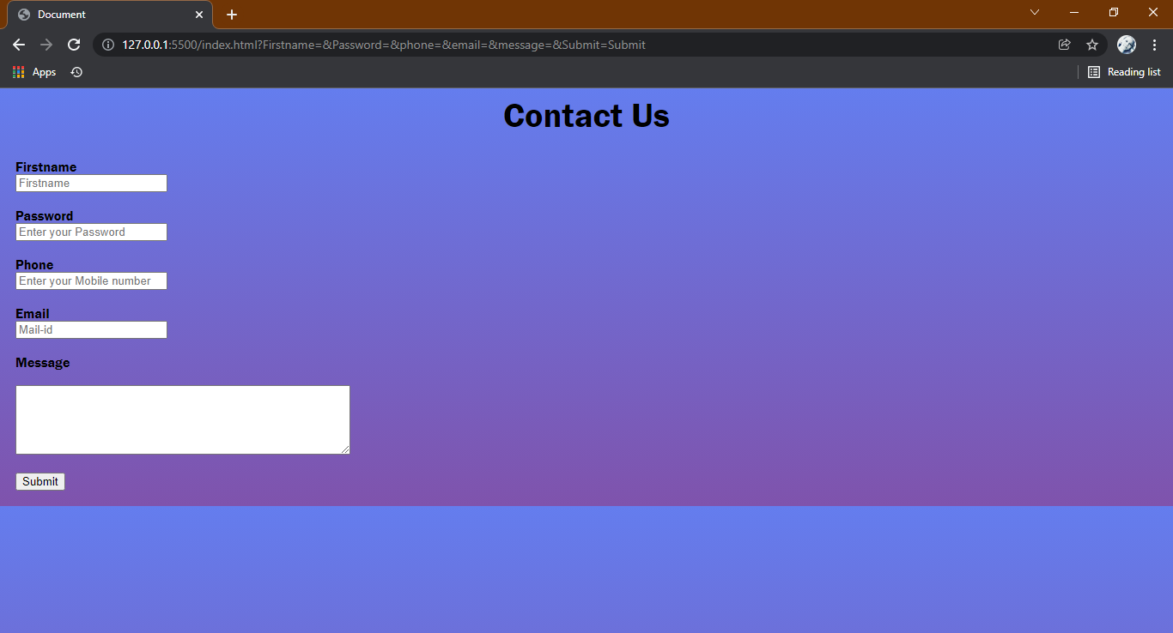

4. Use certain HTML elements to display the following in a HTML page.

* Programming Language
  + JavaScript
    1. Angular
    2. React
    3. Vue.js
  + Python
    1. Django Framework
    2. Flask Framework
  + Java
    1. Spring
    2. Maven
    3. Hibernate
* Database
  + MySQL
  + MongoDB
  + Cansandra

Code:

<!DOCTYPE html>

<html lang="en">

<head>

  <title>Document</title>

</head>

<body>

   <ul>

    <li>Programming Languages</li>

    <ul>

        <li>JavaScript</li>

        <ol type ="a">

            <li>Angular</li>

            <li>React</li>

            <li>Vue.js</li>

        </ol>

        <li>Python</li>

        <ol type ="a">

        <li>Django Framework</li>

        <li>Flask Framework</li>

        </ol>

        <li>Java</li>

        <ol type ="a">

        <li>Spring</li>

        <li>Maven</li>

        <li>Hibernate</li>

        </ol>

    </ul>

    <li>Database</li><ul>

        <li>MySQL</li>

        <li>MongoDB</li>

        <li>Cansandra</li>

    </ul>

   </ul>

</body>

</html>

Output:

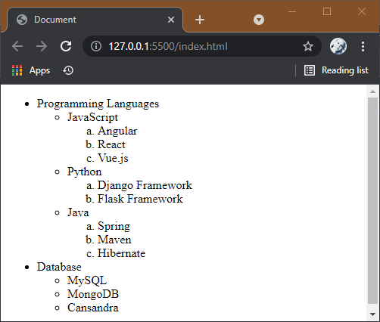

5. Create an element that helps you to open the https://google.com in separate new tab

Code:

 <a href="https://www.google.com/" target="_blank">Google </a>

Output:

[Google](https://www.google.com/)

6.In the form, add two radio buttons with grouping them for employee type(Salaried and own business)

HTML

<body>

  <form>

    <p>Employee-Tpe</p>

    <input type = "radio" name="employee-type" value="Salaried"/>

    <lable for="Salaried">Salaried</lable><br>

    <input type = "radio" name="employee-type" value="Own-Business"/>

    <lable for="Own-Business">Own-Business</lable><br>

  </form>

</body>

OUTPUT

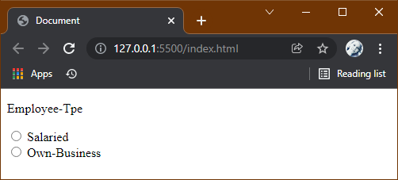

8.Use the table tag to design given image Click here

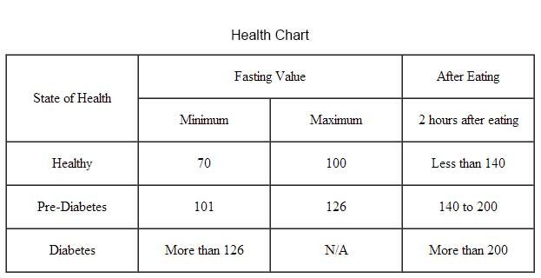

Code:

<!DOCTYPE html>

<html>

<head>

    <title>Document</title>

</head>

<body>

<h3 style="text-align:center;">Health Chart</h3>

<table border="1" align="center" >

        <tr align ="center">

            <td rowspan="2">State of Health </td>

            <td colspan="2">Fasting Value </td>

            <td>After Eating </td><br/>

            </tr>

        <tr>

            <td>Minimum </td>

            <td>Maximum </td>

            <td>2 Hours after Eating </td>

        </tr>

        <tr>

            <td>Healthy</td>

            <td>70 </td>

            <td>100 </td>

            <td>Less than 140 </td>

        </tr>

        <tr>

            <td>Pre-Diaetets</td>

            <td>101 </td>

            <td>126 </td>

            <td>140 to 200 </td>

        </tr>

        <tr>

            <td>Diaetets</td>

            <td>More than 126 </td>

            <td>N/A </td>

            <td>More than 200 </td>

        </tr>

</table>

</body>

</html>

Output:

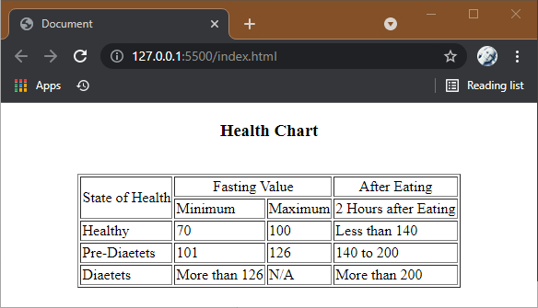

1. Write HTML input tags snippet to show default values for all Form elements

<!DOCTYPE html>

<html lang="en">

  <head>

    <meta charset="UTF-8" />

    <meta http-equiv="X-UA-Compatible" content="IE=edge" />

    <meta name="viewport" content="width=device-width, initial-scale=1.0" />

    <title>Document</title>

    <link rel="stylesheet" href="css/style.css" />

  </head>

  <body>

    <h1>HTML PAGE WITH ALL INPUT FIELDS</h1>

    <label>Enter the Name</label>

    <input type="text" name:"Name"><br />

    <label>Enter the password</label>

    <input type="password" name:"password"><br />

    <lable>Kindly select your Gender </lable><br />

    <input type= "radio" name:"Gender" value="Male">Male<br />

    <input type= "radio" name:"Gender" value="Male">Female<br />

    <input type= "radio" name:"Gender" value="Male">Others<br />

    <lable>Kindly select your Favorite Genre </lable><br />

    <input type="checkbox" name:"Books" value="Fantasy">Fantasy<br />

    <input type="checkbox" name:"Books" value="Horror">Horror<br />

    <input type="checkbox" name:"Books" value="Science

    Fiction">Science-Fiction<br />

    <input

      type="button"

      value="Subscribe..!"

      onclick="alert('Subscribed')"

    /><br />

    <label>Select a file to Upload</label>

    <input type="file" name:"newfile"><br />

    <label for="image">Image</label><br />

    <input

      type="image"

      src="https://encrypted-tbn0.gstatic.com/images?q=tbn:ANd9GcRGJsOP3Ct9mJkjx45Qe0lSH1unurJOSx0t5g&usqp=CAU"

    /><br />

    <label for="color">Color</label>

    <input type ="color" name:"upclick" value="#a52a52"><br />

    <label for="date">Select the Date and time</label>

    <input type="datetime-local" name:"meetingtime" ><br />

    <label>Enter Your Email Address</label>

    <input

      type="email"

      name="email"

      placeholder="Enter Mail-Id"

      required

    /><br />

    <label>Enter Your Birth-Month</label>

    <input type="month" name="newmonth" /><br />

    <label>Enter the current week</label>

    <input type="week" name:"currentweek"><br />

    <label>Enter Your Age</label>

    <input type = "number" name:"num" min:"18" max:"100"><br />

    <lable>Follow us</lable>

    <input type = "url" name:"website" placeholder:"http://xyz.com"><br />

    <lable>Search Here: </lable>

    <input type="search" /><input type="submit" value:"Search"><br />

    <lable>Enter your Telephone Number</lable>

    <input type="tel" pattern="[0-9]" required /><br />

    <input type="submit" value="Submit" /><input

      type="reset"

      value="Reset"

    /><br />

  </body>

</html>

CSS

h1 {

*font-weight*: bolder;

*text-align*: center;

}

body {

*font-size*: 25px;

*display*:block;

*font-family*:'Gill Sans', 'Gill Sans MT', Calibri, 'Trebuchet MS', sans-serif;

*background*:linear-gradient( #c06c84, #ad5389);

}

input {

*padding*: 12px 20px;

*box-sizing*:border-box;

*border-radius*: 8px;

}

OUTPUT

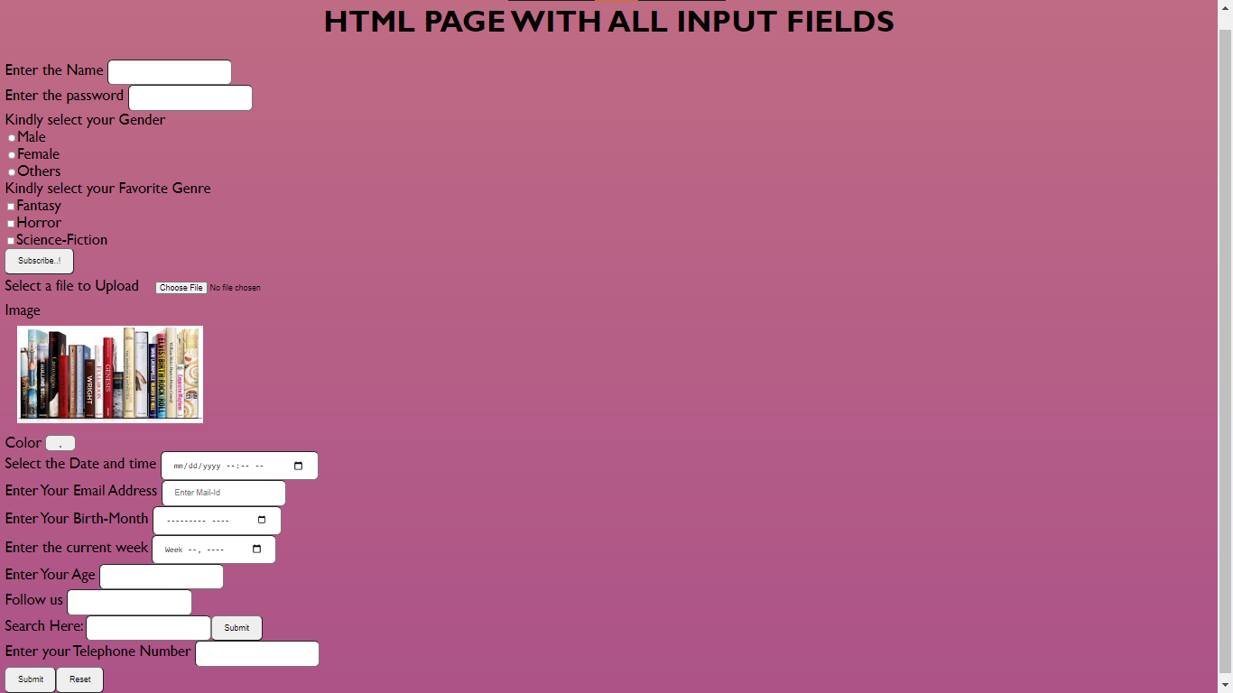

10. In your, HTML page add the below line and Highlight it without using any CSS.

"HTML & CSS is awesome"

<h1><mark>HTML & CSS is awesome</mark></h1>

OUTPUT

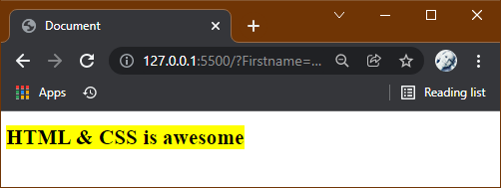

Create an HTML page, which should contain all types of input elements

<!DOCTYPE html>

<html lang="en">

  <head>

    <meta charset="UTF-8" />

    <meta http-equiv="X-UA-Compatible" content="IE=edge" />

    <meta name="viewport" content="width=device-width, initial-scale=1.0" />

    <title>Document</title>

    <link rel="stylesheet" href="css/style.css" />

    <script src="js/jquery.min.js"></script>

    <script src="js/bootstrap.min.js"></script>

  </head>

  <body>

    <header> ABC CINEMA -Ticket Booking </header>

    <form>

        <label for="Name">Name</label>

      <input type="text" name="Firstname" placeholder="Enter your Fullname" />

      <label for="Password">Password</label>

      <input type="password" name="Password" placeholder="Enter your Password"/>

      <label for="phone">Phone</label>

      <input type="tel" name="phone" placeholder="Enter your Mobile number" pattern="[0-9]"/>

      <label for="email">Email</label>

      <input type="email" name="email" placeholder="Mail-id" />

      <label for ="booking-time">Booking(Date and Time)</label>

      <input type = "datetime-local">

        <label for ="movies">Choose a Movie</label>

        <select id="movies" name="movies">

            <option value="1"> Spider-Man:No Way Home </option>

            <option value="2">Pushpa: The Rise </option>

            <option value="3">The Matrix Resurrections</option>

            <option value="4">Bachelor </option>

            </select>

      <label for="radio">Ticket Type</label>

      <input type="radio" id="standard" value="Standard"/><label for="Standard">Standard</label><br>

      <input type="radio" id="vip" value="VIP"/><label for="VIP">VIP</label>

      <label for="No of Seats">Number of Seats</label>

      <input type="number" min="1">

      <label for="message">Additional Comments</label><br />

      <textarea name="message" rows="5" cols="50"></textarea><br>

            <input type="submit" name="Submit" value="BOOK" />

    </form>

  </body>

</html>

CSS:

header{

*font-size*:40px;

*font-weight*:bolder;

*text-align*:center;

  }

  body{

*width*: 90%;

*font-family*:'Lucida Sans', 'Lucida Sans Regular', 'Lucida Grande', 'Lucida Sans Unicode', Geneva, Verdana, sans-serif;

*background-color*: #fdbb2d;

*padding*:5%;

  }

  form{

*white-space*: pre-line;

*padding*:10px;

*border-radius*:5px;

*font-weight*:500 ;

*background*:linear-gradient(#fdbb2d,#3a1c71)

  }

  input{

*padding*:12px 20px;

*box-sizing*: border-box;

*border-radius*: 8px;

  }

OUTPUT:

